# Experiment No: 6

**Aim:**

Familiarisation of Linux Commands.

# CO2:

Perform System Administration tasks.

# Procedure:

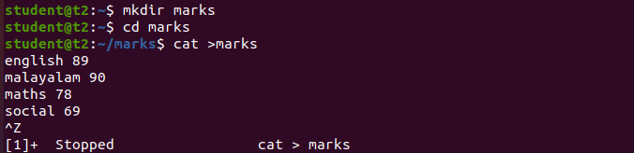

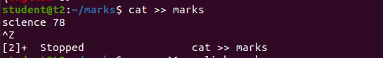



1)grep -used to filter the content which make our search easy

a)grep [search word][filename]



b)grep -i[search word][filename]



c)grep -v[search word][filename]



d)grep -A1[search word][filename]



e)grep -B1[search word][filename]



f)grep -C1[search word][filename]

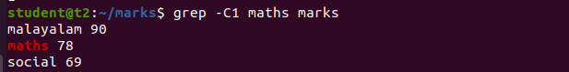

2)head- To display the contents of the file. by default it displays first 10 lines.

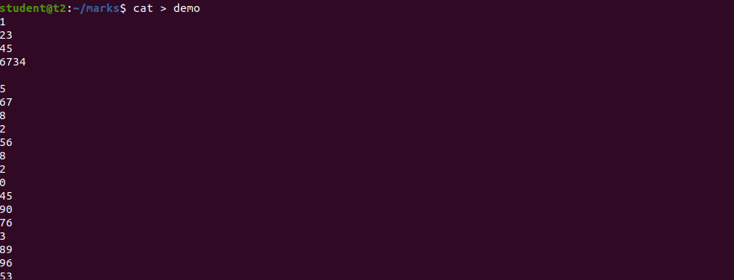

a)head [filename]

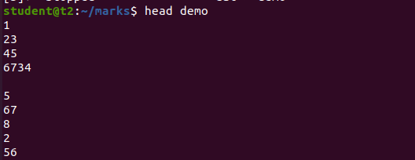

b)head -[limit][filename]

head -5 marks

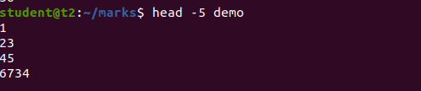

3)tail - To display the last contents of the file

a)tail[filename]

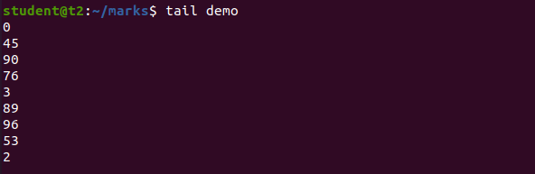

b)tail -[limit] [filename] To display the last contents of the file up to the limit

tail -5 demo

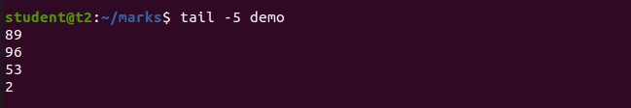

4)mv- used for moving a file from one location to another .its way of replacing the file already written files will be overwritten.

a)mv [file][file2] To move contents from one file to another

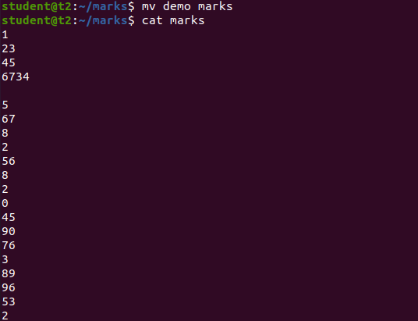

b)mv -b [file][file] Backup contents in the fiile

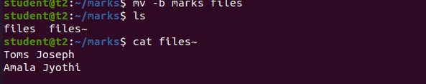

c) mv -i [file1][file2] to display the prompt message (ie : come lyk message is we want to backup or not)

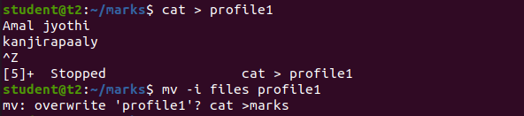

# Result:

The program was executed and the result was successfully obtained. Thus CO2 was obtained.